**Create a DB Schema for Hospital Management System.**

**Define the schema along with the constraints indicating the relationships between the entities.**

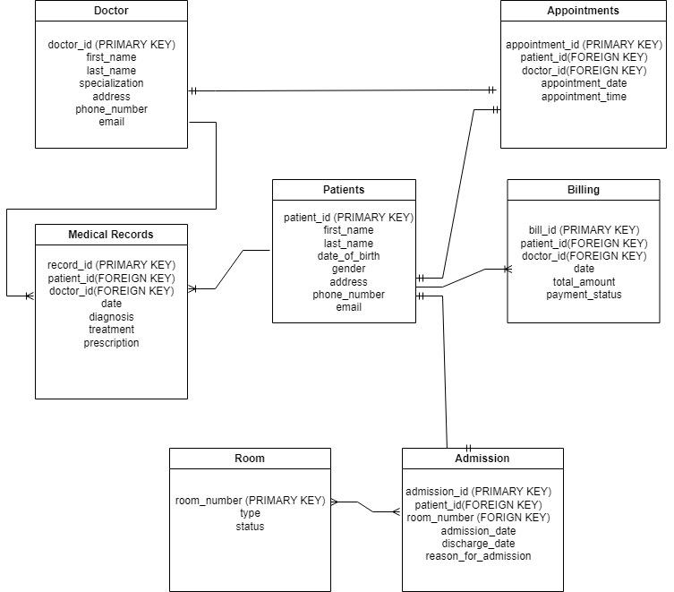

**Patients(**patient_id (Primary Key),first_name,last_name,date_of_birth,gender

,address,phone_number,email)

Patients patient_id refers Appointments patient_id,

Patients patient_id refers Medical Records patient_id,

Patients patient_id refers Billing patient_id,

Patients patient_id refers Admissions patient_id

**Doctors (**doctor_id (Primary Key),first_name,last_name,date_of_birth,gender, address,

phone_number,email)

Doctors doctor_id refers Appointments doctor_id,

Doctors doctor_id refers Medical Records doctor_id,

**Appointments(**appointment_id,patient_id,doctor_id ,appointment_date,appointment_time)

Appointments patient_id(FK) refers Patient patient_id,

Appointments patient_id(FK) refers Doctor doctor_id,

**Medical Records(**record_id,patient_id,doctor_id,date,diagnosis,treatment,prescription,

prescription)

Medical Recordspatient_id(FK) refers Patient patient_id,

Medical Records patient_id(FK) refers Doctor doctor_id,

**Billing table(**bill_id ,patient_id ,doctor_id,date,total_amount,payment_status)

Billing patient_id(FK) refers Patient patient_id,

Billing patient_id(FK) refers Doctor doctor_id,

**Rooms(**room_number(PK), type, status)

Rooms room_number(PK) refers admission room_number

**Admissions (**admission_id,patient_id,room_number,

admission_date,discharge_date,reason_for_admission)

Admissions patient_id(FK) refers Patient patient_id,

Admissions room_number refer Rooms room_number,

// CREATION OF DATABASE

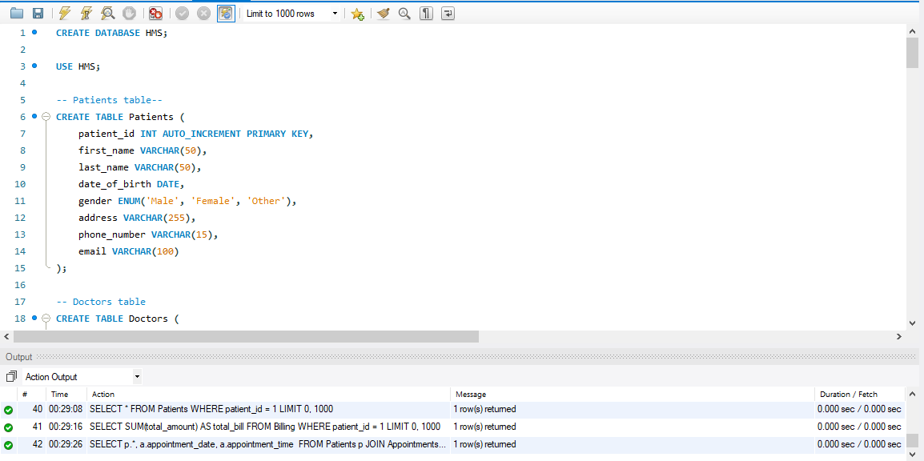

**CREATE DATABASE HMS;**

**USE HMS;**

**-- Patients table--**

CREATE TABLE Patients (

patient_id INT AUTO_INCREMENT PRIMARY KEY,

first_name VARCHAR(50),

last_name VARCHAR(50),

date_of_birth DATE,

gender ENUM('Male', 'Female', 'Other'),

address VARCHAR(255),

phone_number VARCHAR(15),

email VARCHAR(100)

);

**-- Doctors table**

CREATE TABLE Doctors (

doctor_id INT AUTO_INCREMENT PRIMARY KEY,

first_name VARCHAR(50),

last_name VARCHAR(50),

specialization VARCHAR(100),

address VARCHAR(255),

phone_number VARCHAR(15),

email VARCHAR(100)

);

**-- Appointments table**

CREATE TABLE Appointments (

appointment_id INT AUTO_INCREMENT PRIMARY KEY,

patient_id INT,

doctor_id INT,

appointment_date DATE,

appointment_time TIME,

FOREIGN KEY (patient_id) REFERENCES Patients(patient_id),

FOREIGN KEY (doctor_id) REFERENCES Doctors(doctor_id)

);

**-- Medical Records table**

CREATE TABLE Medical_Records (

record_id INT AUTO_INCREMENT PRIMARY KEY,

patient_id INT,

doctor_id INT,

date DATE,

diagnosis VARCHAR(255),

treatment VARCHAR(255),

prescription VARCHAR(255),

FOREIGN KEY (patient_id) REFERENCES Patients(patient_id),

FOREIGN KEY (doctor_id) REFERENCES Doctors(doctor_id)

);

**-- Billing table**

CREATE TABLE Billing (

bill_id INT AUTO_INCREMENT PRIMARY KEY,

patient_id INT,

doctor_id INT,

date DATE,

total_amount DECIMAL(10, 2),

payment_status ENUM('Pending', 'Paid'),

FOREIGN KEY (patient_id) REFERENCES Patients(patient_id),

FOREIGN KEY (doctor_id) REFERENCES Doctors(doctor_id)

);

**-- Rooms table**

CREATE TABLE Rooms (

room_number INT AUTO_INCREMENT PRIMARY KEY,

type VARCHAR(50),

status ENUM('Occupied', 'Vacant')

);

**-- Admissions table**

CREATE TABLE Admissions (

admission_id INT AUTO_INCREMENT PRIMARY KEY,

patient_id INT,

room_number INT,

admission_date DATE,

discharge_date DATE,

reason_for_admission VARCHAR(255),

FOREIGN KEY (patient_id) REFERENCES Patients(patient_id),

FOREIGN KEY (room_number) REFERENCES Rooms(room_number)

);

**SHOW TABLES;**

**-- Insert data into Appointments table**

INSERT INTO Appointments (patient_id, doctor_id, appointment_date, appointment_time)

VALUES (1, 1, '2024-02-21', '10:00:00');

**-- Insert data into Billing table**

INSERT INTO Billing (patient_id, doctor_id, date, total_amount, payment_status)

VALUES (1, 1, '2024-02-21', 100.00, 'Pending');

**-- Insert data into Rooms table**

INSERT INTO Rooms (type, status)

VALUES ('Private', 'Vacant');

**-- Insert data into Admissions table**

INSERT INTO Admissions (patient_id, room_number, admission_date, discharge_date, reason_for_admission)

VALUES (1, 1, '2024-02-21', '2024-02-25', 'High fever');

**-- - 1 Write necessary queries to register new user roles and personas**

**-- Registering a new patient**

INSERT INTO Patients (first_name, last_name, date_of_birth, gender, address, phone_number, email)

VALUES ('Deepak', 'Mishra', '2003-09-02', 'Male', 'Mharal, Kalyan', '125-678-9012', 'deepakmishra@gmail.com');



**-- Registering a new doctor**

INSERT INTO Doctors (first_name, last_name, specialization, address, phone_number, email)

VALUES ('Dr. Satyam', '', 'Mishra', 'Varap, Kalyan', '987-654-3210', 'satyammishra@gmail.com');



**-- - 2 Write necessary queries to add to the list of diagnosis of the patient tagged by date.**

INSERT INTO Medical_Records (patient_id, doctor_id, date, diagnosis, treatment, prescription)

VALUES (1, 1, '2024-02-21', 'Fever', 'Rest and fluids', 'Paracetamol');



**-- - 3 Write necessary queries to fetch required details of a particular patient.**

SELECT * FROM Patients WHERE patient_id = 1;



**-- - 4 Write necessary queries to prepare bill for the patient at the end of checkout.**

SELECT patient_id, SUM(total_amount) AS total_bill FROM Billing WHERE patient_id = 1;



**-- - 5 Write necessary queries to fetch and show data from various related tables (Joins)**

SELECT p.*, a.appointment_date, a.appointment_time

FROM Patients p

JOIN Appointments a ON p.patient_id = a.patient_id

WHERE p.patient_id = 1;



**-- - 6 Optimize repeated read operations using views/materialized views.**

CREATE VIEW Patient_Appointment_Details AS

SELECT p.*, a.appointment_date, a.appointment_time

FROM Patients p

JOIN Appointments a ON p.patient_id = a.patient_id;



**-- - 7 Optimize read operations using indexing wherever required. (Create index on at least 1 table)**

CREATE INDEX idx_patient_id ON Patients(patient_id);

**-- - 8 Try optimizing bill generation using stored procedures.**

DELIMITER //

CREATE PROCEDURE Generate_Bill(IN patient_id INT)

BEGIN

DECLARE total DECIMAL(10, 2);

SELECT SUM(total_amount) INTO total FROM Billing WHERE patient_id = patient_id;

SELECT total;

END //

DELIMITER ;

CALL Generate_Bill(1);



**-- - 9 Add necessary triggers to indicate when patients medical insurance limit has expired.**

DELIMITER //

CREATE TRIGGER Insurance_Expiration

BEFORE INSERT ON Admissions

FOR EACH ROW

BEGIN

IF NEW.admission_date < DATE_SUB(NOW(), INTERVAL 1 YEAR) THEN

SIGNAL SQLSTATE '45000' SET MESSAGE_TEXT = 'Patient\'s medical insurance limit has expired';

END IF;

END //

DELIMITER ;

Q2) Write a report on your understanding of Rendering and Design Patterns. Mention and elaborate where a particular Rendering pattern is applicable and is well suited for which use case.

**Ans :-**

**Introduction:**

Rendering is a crucial aspect of software development, particularly in fields like computer graphics, game development, and user interface design. It involves the process of generating an image from a model by means of computer software.

**Rendering Techniques:**

**•Immediate Mode Rendering:**

Rendering commands are issued directly to the graphics hardware for immediate execution. It is suitable for applications requiring real-time interaction and responsiveness, such as video games and simulations.

**•Retained Mode Rendering:**

This technique involves constructing a scene graph or retaining a representation of the scene in memory, which is then rendered to the screen. Retained mode rendering is commonly used in graphical user interfaces (GUIs) and applications where scene complexity is high and pre-processing can improve rendering performance.

**Design Patterns in Rendering:**

**Factory Method Pattern:**

This pattern is used to create objects without specifying the exact class of the object to be created. In rendering, the factory method pattern can be applied to create different types of rendering objects (e.g., renderers, shaders) based on specific requirements or configurations.

**Composite Pattern:**

The composite pattern is used to represent hierarchical structures as a tree of objects. In rendering, the composite pattern can be employed to represent complex scenes composed of multiple objects and sub-objects, enabling efficient rendering and manipulation of the scene graph.

**Observer Pattern:**

This pattern is used to establish a one-to-many dependency between objects, where changes in one object trigger updates in dependent objects. In rendering, the observer pattern can be utilized to implement event-driven rendering systems, where changes in the scene trigger updates in the rendering pipeline.

**Conclusion :-**

rendering patterns play a vital role in shaping the design and implementation of rendering systems, enabling developers to tackle challenges effectively and deliver compelling visual experiences across a wide range of applications.